Web Programming
Class Task-2
Archery Game

AI Analysis Report

Submitted by
Muhammad Moiz Ansari 23i-0523

Semester-6

Submitted to
Ma’am Tajwar


Department of Computer Science National University of Computer and Emerging Sciences Islamabad, Pakistan

Contents
Prompt Given 3
Games by AI 6
1. Claude 6
2. Deep Seek 6
3. Gemini 7
4. Qwen 7
5. Chat Gpt 8
6. Grok 8
AI Agent Comparison Ratings 8
Analysis 8
1. Claude 8
2. DeepSeek 9
3. Gemini 9
4. Qwen 9
5. Chat GPT 9
6. Grok 9
Conclusion 9

Prompt Given
Write the code for making an archery game following the instructions inside the pdf doc attached
Only HTML + CSS + JavaScript allowed
All the images are inside the folder "sprites"
Sprites Folder Structure:
The art style is consistent, using a semi-realistic, illustrated vector style with a focus on wooden textures and outdoor environments.

1. Player Equipment (Animation & Logic)
The Bow (bow1.png to bow6.png):

Visuals: A classic wooden recurve bow.

Animation Logic: These 6 frames create a smooth "draw" animation.

Bow1: Resting state (string straight).

Bow2–Bow5: Transition frames showing the string being pulled back and the wooden limbs bending under tension.

Bow6: Full draw (maximum tension), ready to release.

The Arrow (arrow.png):

Visuals: A single wooden shaft with a silver metal tip and pink/red fletching (feathers). It faces right, matching the direction of the bow.

The Quiver/Ammo UI (bag1.png to bag4.png):

Visuals: A brown leather arrow case (quiver).

Game Logic: You have a clear visual indicator for remaining ammo:

Bag1: 3 arrows visible (Full).

Bag2: 2 arrows visible.

Bag3: 1 arrow visible.

Bag4: Empty quiver (Game Over/Out of ammo state).

2. Targets & Scoring
Target Sprite (target.png):

Visuals: A standard 5-color archery target (Gold, Red, Blue, Black, White).

Perspective: It is drawn at an angle (slightly side-profile), giving the game a sense of depth rather than being flat 2D.

Scoring Guide (target_scores.png):

Visuals: The same target sprite with an overlay of text and lines explaining the hit zones.

Values:

50 pts: Gold (Bullseye)

30 pts: Red ring

15 pts: Blue ring

10 pts: Black ring

5 pts: White ring

3. User Interface (UI) & Branding
Main Logo (logo.png):

A high-quality badge showing a bow, a target with an arrow in the bullseye, and the title "PRECISION SHOT" on a wooden plaque. Surrounded by a laurel wreath (symbol of victory).

App Icon (favicon.png):

A simplified circular version of the logo without the text, suitable for a browser tab icon or mobile app icon.

UI Elements:

button.png: A simple wooden rectangular plank. This is a reusable asset for menu buttons (e.g., "Start," "Settings").

menu-bg.png: A dark, textured rectangular background (looks like dark parchment or leather). Likely used as a backdrop for the pause menu or score screen to make white text pop.

4. Environments (Backgrounds)
Main Menu Background (bg-main.jpg):

Visuals: A highly detailed forest scene. It features a tree in the foreground with a target attached to it, and a moody, misty forest in the back.

Note: This file is a .jpg and is the largest file (~1.8 MB), which makes sense as it is a high-resolution static image for the title screen.

Gameplay Background (bg-game.png):

Visuals: A softer, hazier landscape (golden/sunset lighting).

Design Choice: The "blurry" or soft style is excellent for gameplay because it ensures the sharp, crisp sprites (bow, arrow, target) stand out clearly against the background.

-----------------------------------------
I have attached the pdf file with instructions and the target.png so you can calculate the points for calculating points.
additionally, the following are the points from top to bottom of the target.png
w1 = 0 px
wb1 = 54 px
bbl1 = 115 px
blr1 = 182 px
ry1 = 249 px
ry2 = 385 px
blr2 = 451 px
bbl2 = 519 px
wb2 = 579 px
w2 = 634 px
w1 is start of above white, wb1 is end of above white & start of above black, and so on...
Keep the total time=60s, total arrows=15 initially
(target.png)
(Given pdf doc)

Games by AI

Claude
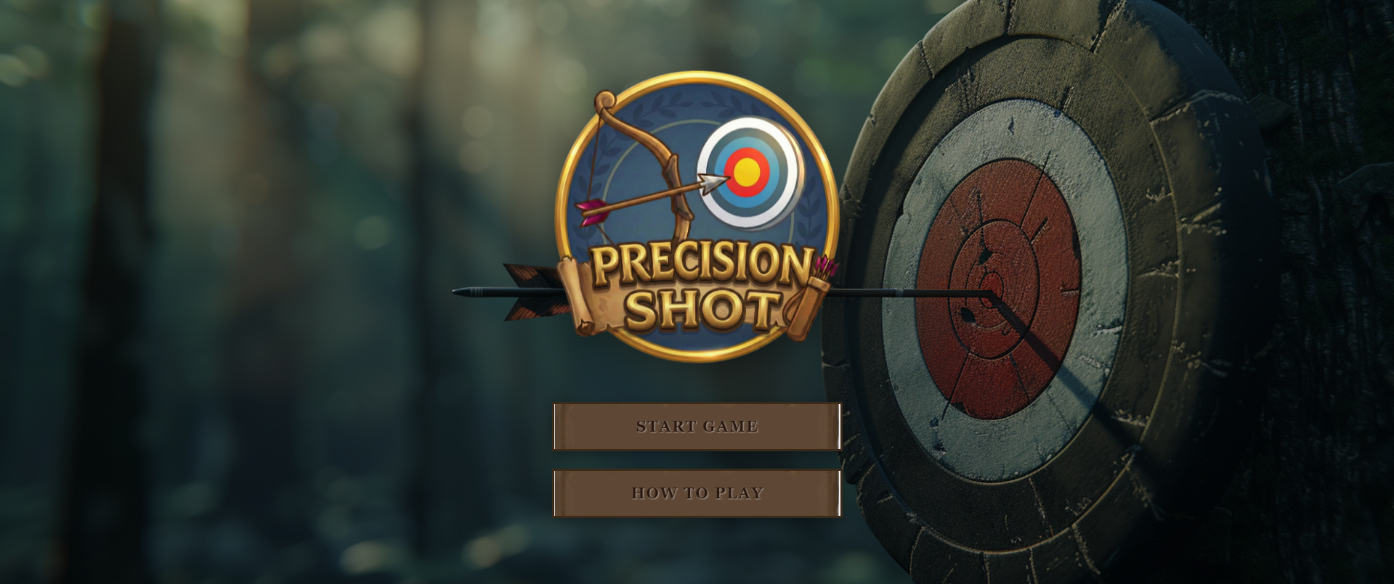
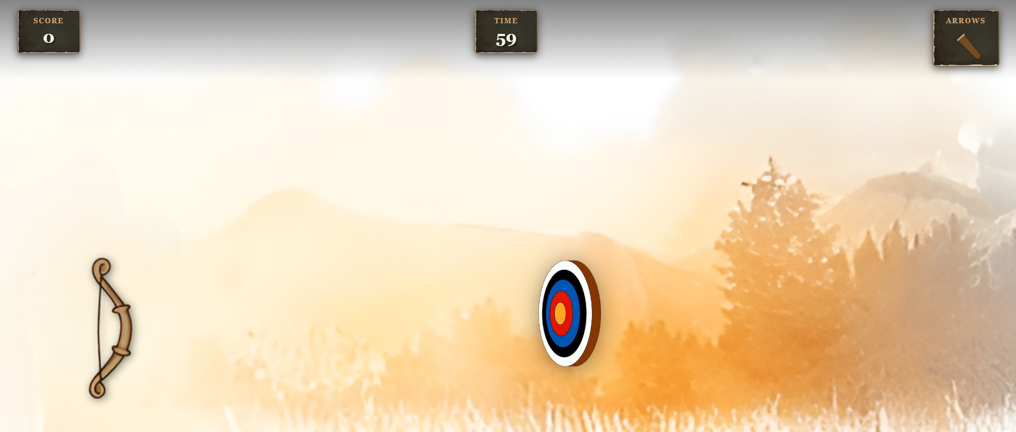

Deep Seek
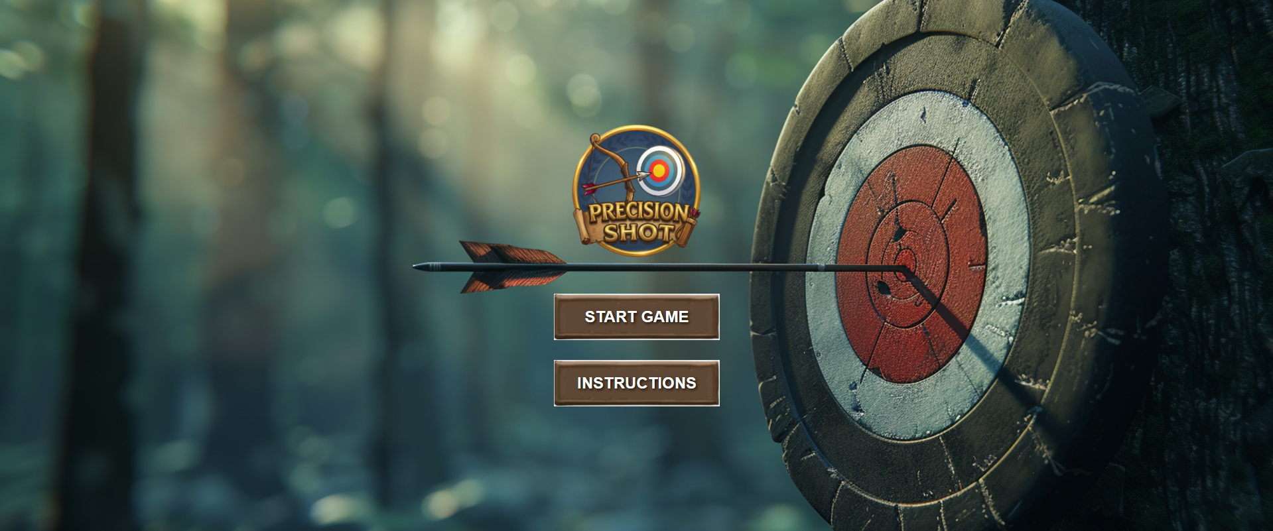
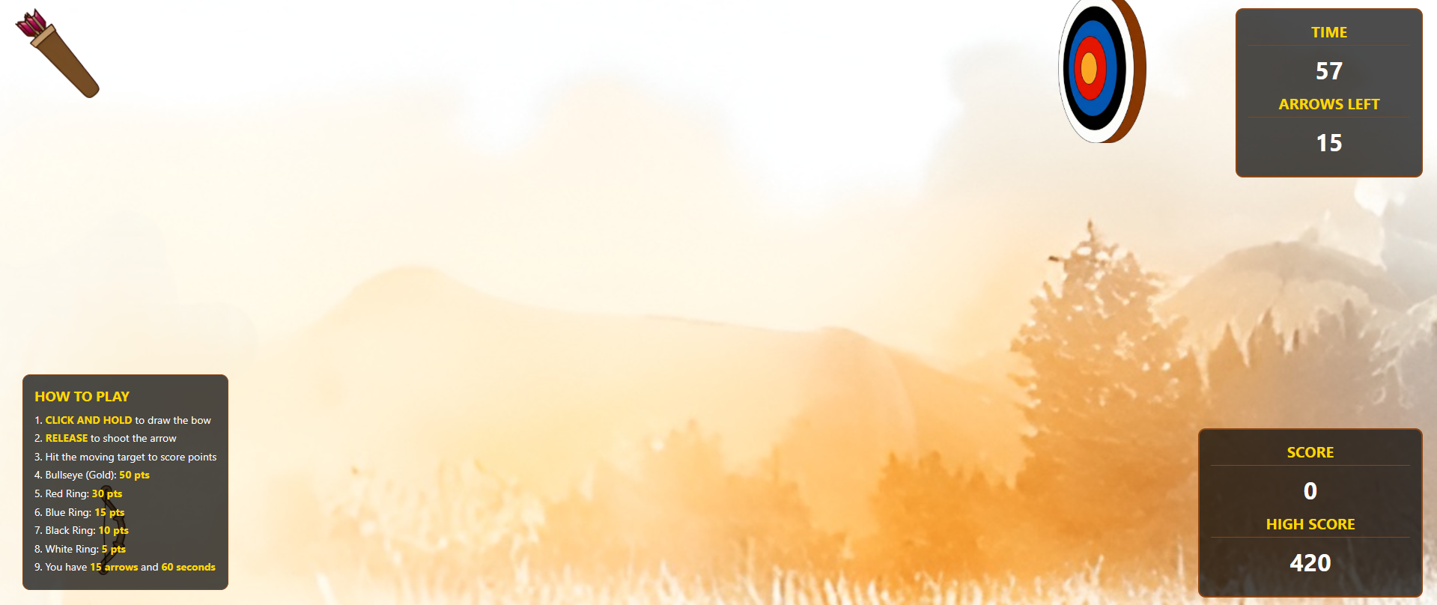

Gemini
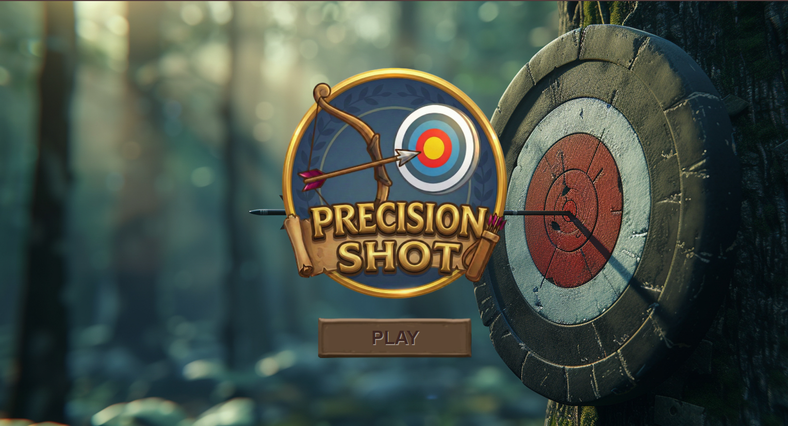
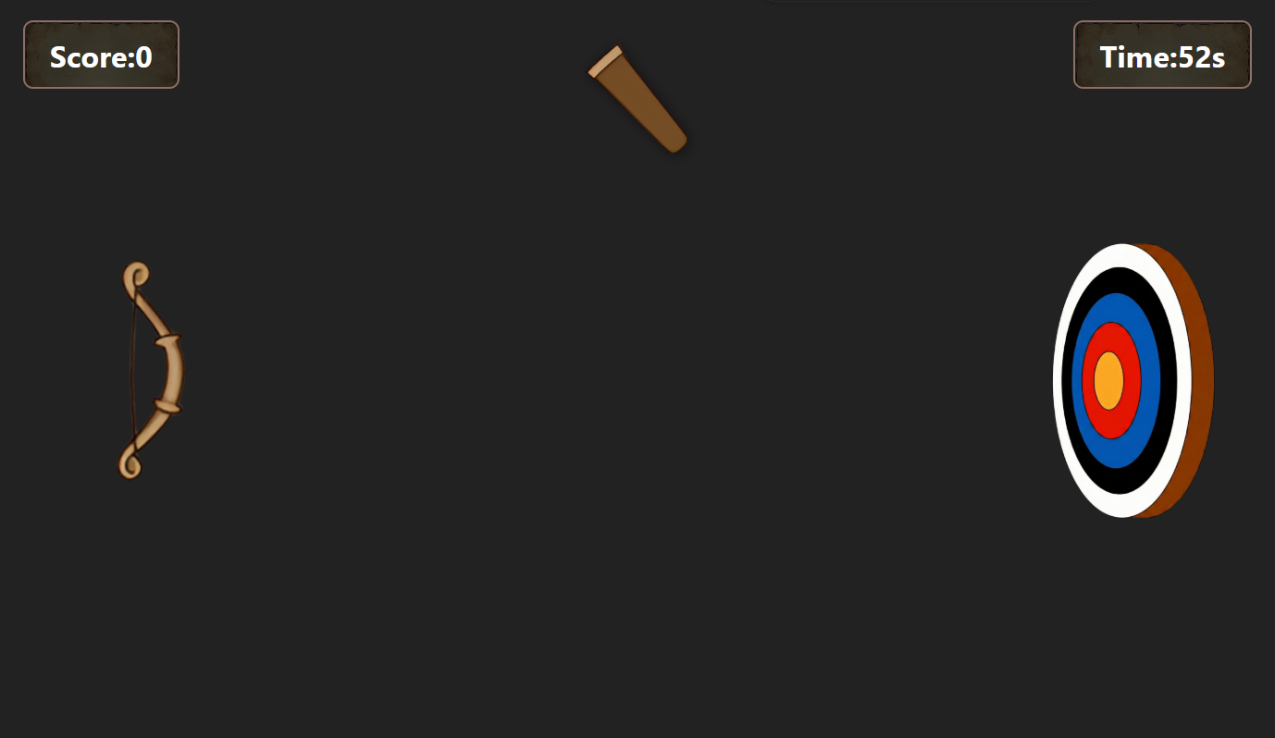

Qwen

Chat Gpt
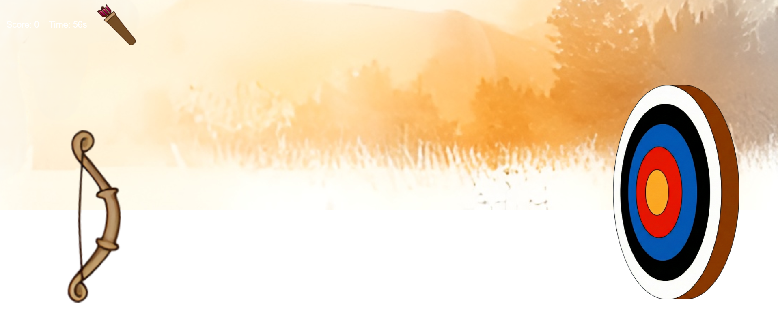

Grok
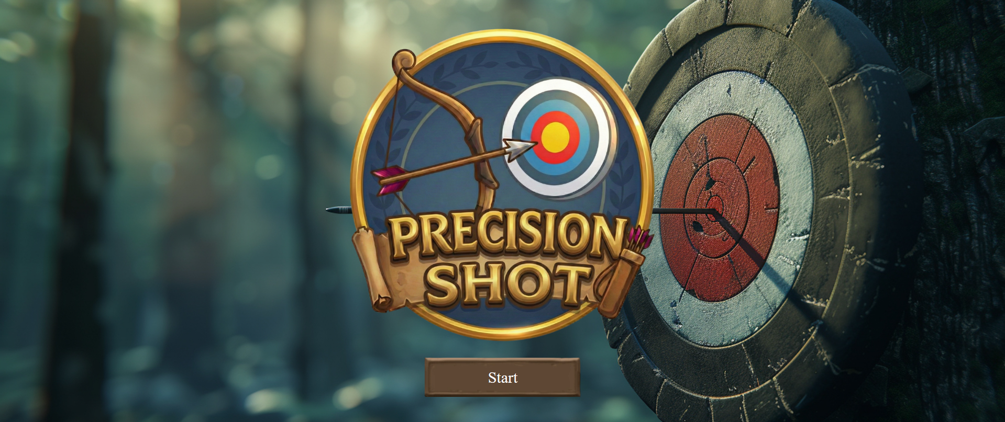
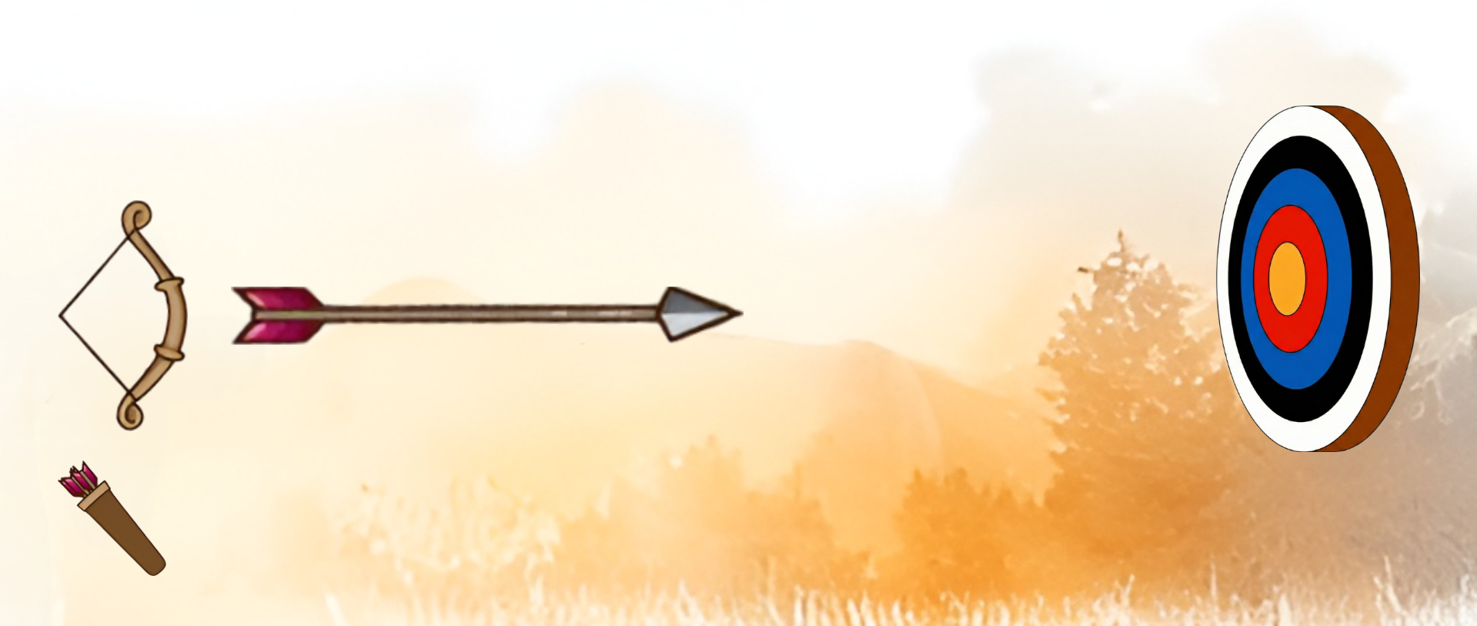

AI Agent Comparison Ratings
- Claude 4.5 Sonnet
- Deep Seek (Deep think Mode)
- Gemini 3 Pro
- Qwen3-Coder
- Chat GPT (Thinking Mode)
- Grok (Expert)

Analysis

Claude
Claude did an outstanding performance once again. It put very unique animations on the menu buttons, utilized the menu bg image, and put shake animation on the target board as well, AND also the shooting of arrows with angles, It’s target moved in all directions diagonally, making game more difficult. It put deceleration or arrow too, which shows how it thinks to keep things close to real life. I would give Claude 10/10 for the perfect, complete website.

DeepSeek
Deep seek also did a very great job. It also added the angle shooting implementation. It added instructions and like Claude, its target was moving in all directions too. It had a bug in movement of target, but the rest was all good. I will give it 9/10.

Gemini
Gemini added all the basic functionality like up and down movement of target, simple bow animation, score increment, shooting collision and everything was working fine. It was like the basic implementation of my own written game. I will give it 8/10.

Qwen
Qwen too failed to understand the assignment. It did implement the shooting of arrow on clicking the bow, and not only that, the arrow moved according to the angle as well. The target’s position was static but got changed every time it hit. The only problem was that target wasn’t moving and the arrow’s direction was fixed to target’s center. So there was no point of playing the game. Also timer didn’t work as well. So I will give it 4/10 for lack of understanding problem.

Chat GPT
Chat GPT was pathetic this time. There was no menu and no styling of CSS to scale down the sprites. Only target was moving and arrow was shooting, but no score update or shown. Very non functional code. I will give it 2/10.

Grok
Grok did a terrible job and it too just made the menu barely. It didn’t even move the target, neither shoot the arrow. Just displayed images on screen. I will give it 1/10.

Conclusion
Overall, most of the AI agents did a good job in understanding the assignment and adding something extra or unique in addition to the original thing because they wanted to put in some creativity. Like the DeepSeek and Claude added diagonal movement of target and angle shooting of arrow. Difference is Claude’s code works 100% and DeepSeek’s have little problems. Gemini does his job like what is given to it and works fine Qwen failed to understand the task. But ChatGPT and Grok are extremely terrible in web development.

